Mythepisode Installation/Configuration Instructions

<http://code.google.com/p/mythepisode/>

Installation of mythepisode only takes a few minutes and can be accomplished with the 5 steps listed below in the installation section.

After an initial install when you first select TV Episodes, mythepisode has to go to TVRage.com and grab a list of shows for the first time so there might be a slight delay (~5-10 seconds). The complete show listing is only grabbed one time unless you explicitly request a new update by selecting “Updating Show Listing”. You shouldn’t have to do this very often.

When you click on a show link for the first time episode information about that show will be retrieved from TVRage.com/TheTVDB.com. After you retrieve the data the first time any subsequent returns to the show won't require data grabbing. You do have the option to re-pull the data at any time. Data will also be pulled again if you visit the show page and the data is older than 14 days (configurable) and the show is still a currently running series. Shows that have ended or canceled won't re-update unless you explicitly request an update.

If summary information doesn't exist at TVRage.com for a particular episode an attempt will be made to get it from TheTVDB.com. The user has the option of selecting TVRage.com or TheTVDB.com as the primary source for episode information.

I have tested mythepisode with the following browsers (although not thoroughly)

• Firefox - very fast on my system

• Safari - very fast on my system

• Chrome - very fast on my system

• Internet Explorer - slow on my system

All Configuration settings are set through the mythweb settings menu. Listed under the installation instructions are all of the configuration options and their purpose.

**Installation Instructions**

Note: If you have never installed mythepisode you should perform all steps. If you are upgrading from a previous version of mythepisode you will only need to perform step 1. If you have upgraded mythtv/mythweb to a new version you will need to do steps 1, 2 and 4. In all cases you should review the configuration options listed after the installation instructions.

As installed on my system (Ubuntu):

**Step 1:**

Download the latest mythepisode gzip file from <http://code.google.com/p/mythepisode/downloads/list>and place it in /tmp. Find the path where mythweb is installed on your system. I'm using Ubuntu which has mythweb installed under /usr/share/mythtv/mythweb. Under the mythweb directory you will find a directory called modules. This is where you will install mythepisode.

* **cd /usr/share/mythtv/mythweb/modules**

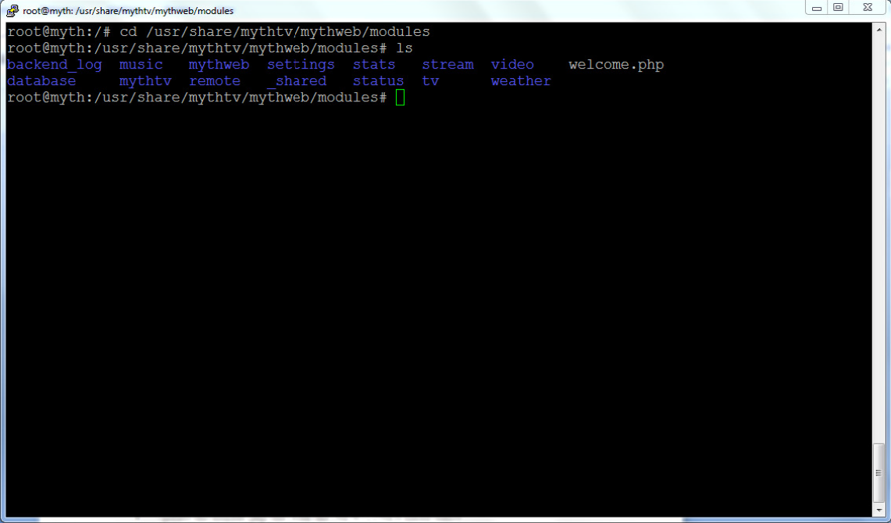

• **tar -zxvf /tmp/episode.tar.gz**

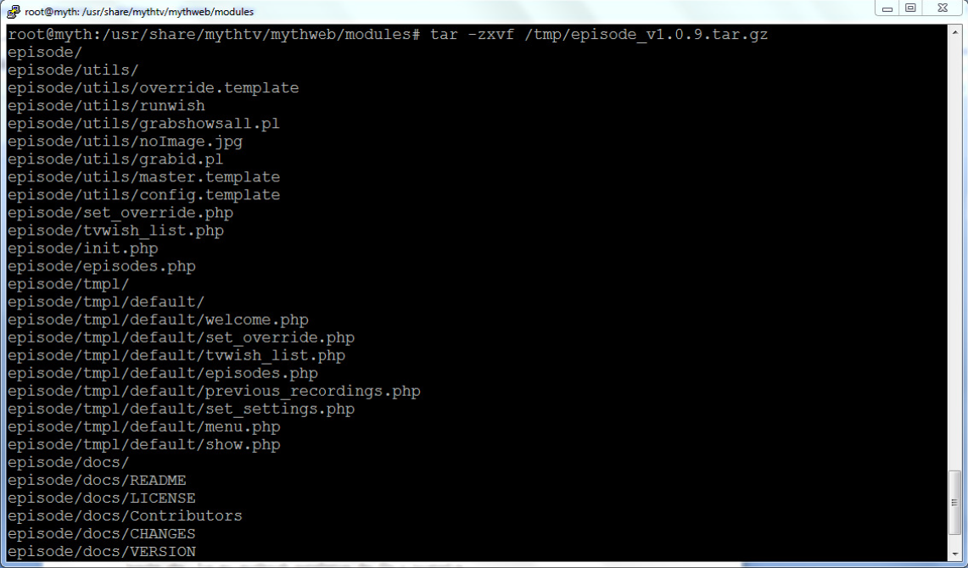

• **ls -lrt**

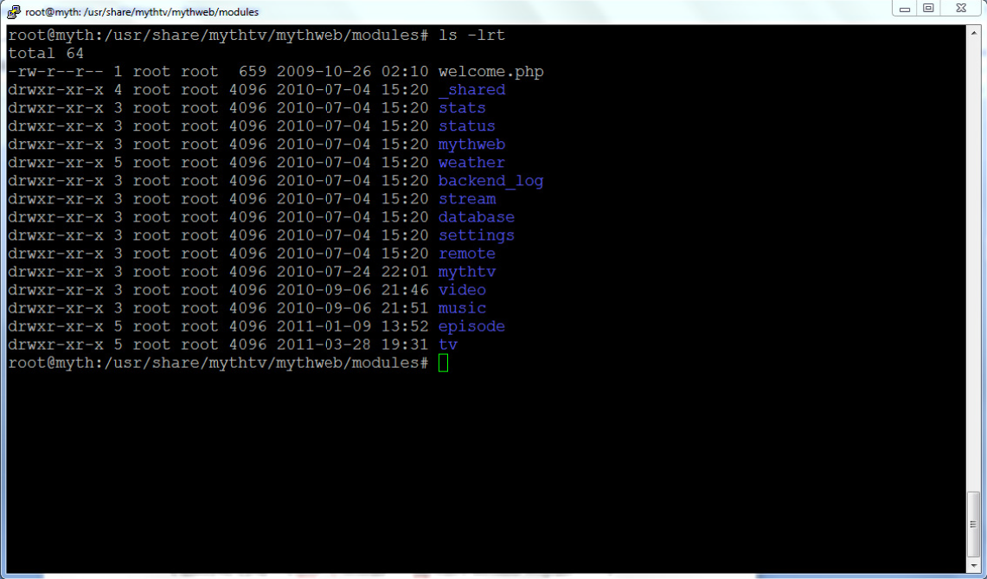

**Step 2:**

Add mythepisode to the mythweb menu by adding the 2 NEW LINE entries listed below to the header.php. For my mythweb installation the file is located in /usr/share/mythtv/mythweb/modules/_shared/tmpl/default/header.php.

• **cd /usr/share/mythtv/mythweb/modules/_shared/tmpl/default**

• **ls**

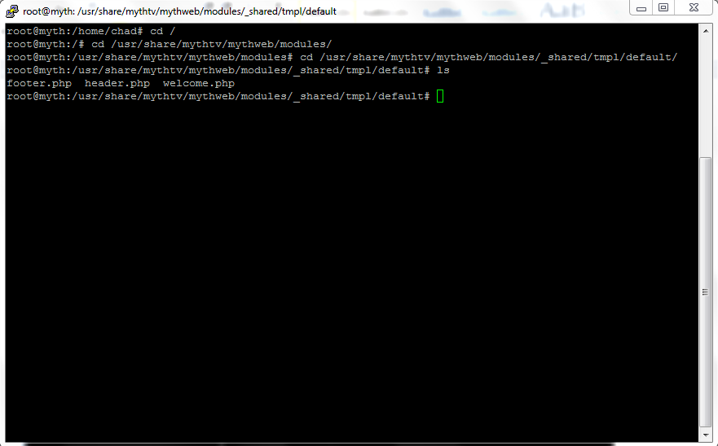

• Update the header.php file with the NEW LINES listed below.

**EXISTING LINE:** <a href="tv/recorded"><?php echo t('Recorded Programs') ?></a>

**EXISTING LINE:** &nbsp; | &nbsp;

**NEW LINE:** <a href="episode"><?php echo t('TV Episodes') ?></a>

**NEW LINE:** &nbsp; | &nbsp;

**EXISTING LINE:** <?php } ?>

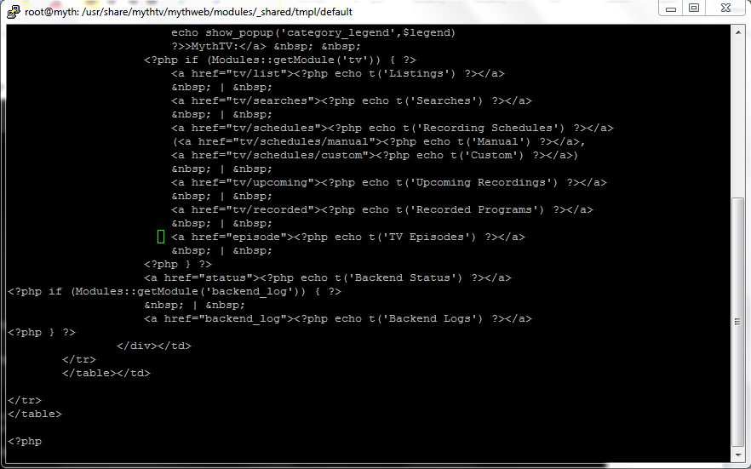

**Step 3:**

Create a directory where you want your show/episode information stored. I use the same directory path where my tv and video recordings are stored. This will ensure that if you update mythweb or mythepisode your data files will not be removed.

• **mkdir /var/lib/mythtv/episode**

This can be wherever you want. My mythtv recordings, movies, etc are stored in directories located under /var/lib/mythtv so this is where I want to create the episode dir.

• **chmod 777 /var/lib/mythtv/episode**

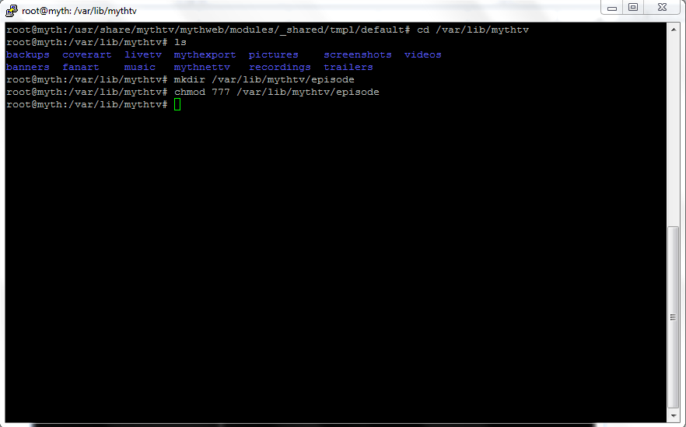

• **cd /usr/share/mythtv/mythweb/data**

The path to the mythweb/data dir may be different for your mythweb installation.

• **ln -s /var/lib/mythtv/episode episode**

• **ls -lrt /usr/share/mythtv/mythweb/data**

This is what my system looks like after the above link is created and I run an ls –lrt command in /usr/share/mythtv/mythweb/data directory

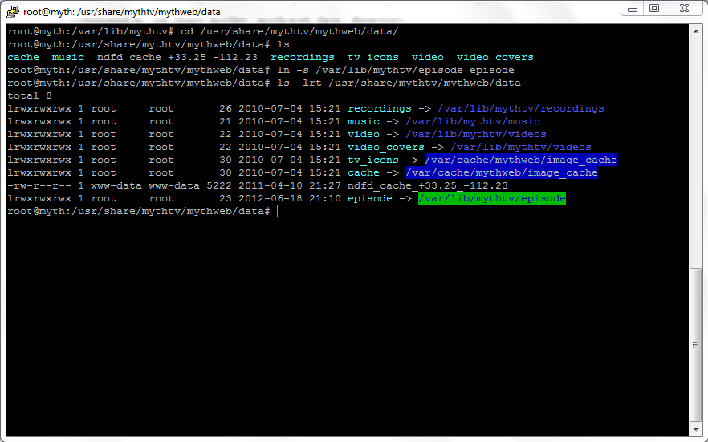

**Step 4:**

Run the mythweb build_translation script.

• **cd /usr/share/mythtv/mythweb/modules/_shared/lang**

• **./build_translation.pl**

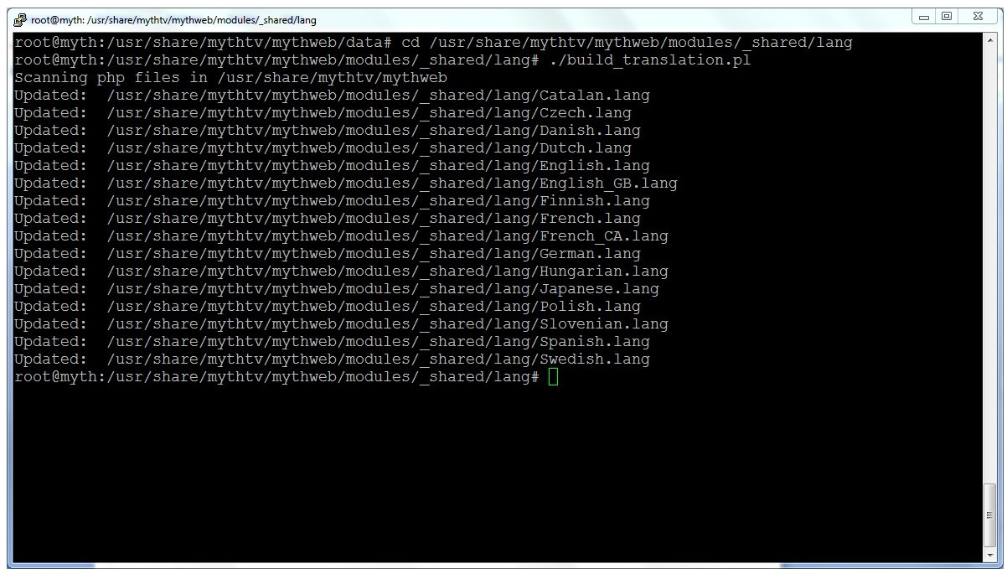

**Step 5: (optional)**

This step is optional, but required if you want to use the tvwish funtion in mythepisode. If you choose not to use this you can disable and hide all tvwish functions by updating the tvwishhide configuration option in the mythweb settings. If you don't install tvwish now you can always do it later if you choose to.

Download tvwish from <http://www.templetons.com/brad/myth/tvwish.html>and install it under

/usr/share/mythtv/tvwish or wherever you would like to install it.

Add a cronjob to roots crontab

**00 12 * * * /usr/share/mythtv/mythweb/modules/episode/utils/runwish > /dev/null 2>&1**

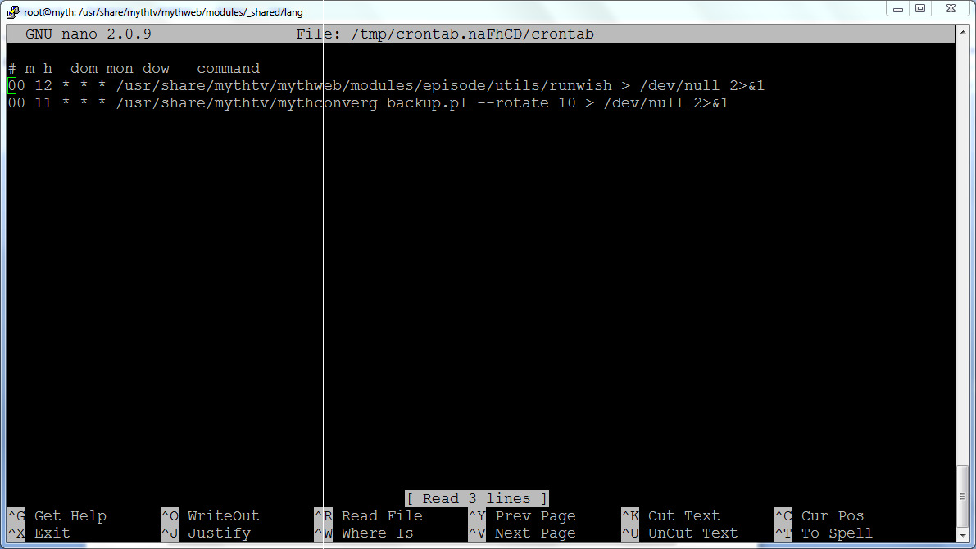

**Note:**

If your paths differ from mine above then you will have to make a few changes to paths in the cronjob and the script below to reference your paths.

• runwish - Found under the mythweb/modules/episode/utils directory

**INSTALLATION IS NOW DONE. CHECKOUT THE CONFIGURATION OPTIONS LISTED BELOW.**

**Configuration options:**

The only setting that you potentially need to change is the value for the mythtv version. You should take a look at these and understand what each setting is used for so that you can make configuration changes to suit your needs. All of these configuration options should be changed from the mythweb settings utility.

**Settings Tab**

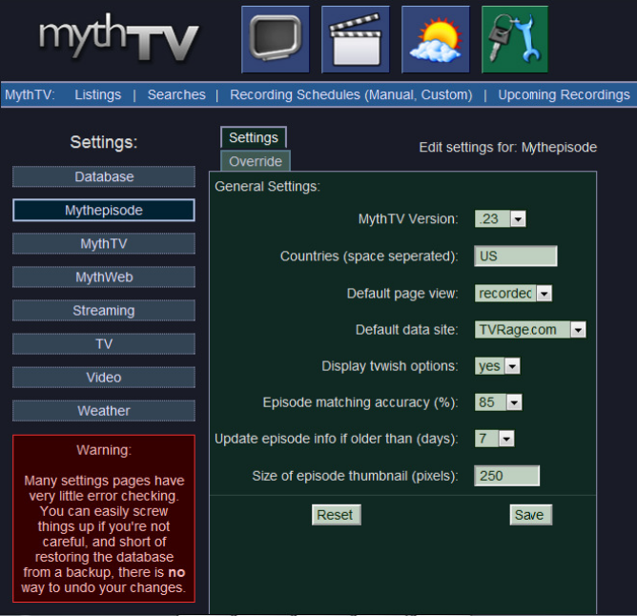

**MythTV Version:**

This option is used to set your currently running mythtv version. The default value is .24+

Options:

• .21

• .22

• .23

• .24+ - Used for .24 and above

**Countries (space separated):**

This option is used to set the country or countries shows that will be retrieved from TVRage.com and displayed in mythepisode. The default is set to "US". Each country should only be 2 characters and separated by a space if more than one country is selected.

**Examples:** US

US CA

US UK CA

After making a change to this setting you will need to do an "Update Shows" from the main mythepisode page.

**Default page view:**

This option is used to determine which page is displayed by default when you select "TV Episodes". The default setting is "recorded".

**Options:**

• **recorded** - Only display shows that have previously recorded

• **current** - Display shows that are currently running tv shows

• **all** - Display every(I'm sure some are missing) TV series that has ever aired

**Default data site:**

This option is used to choose the query site used for grabbing episode information. The default setting is TVRage.com

**Display tvwish options:**

This option is used to turn on/off the display of tvwish options and menus. Some mythepisode users don't want to use tvwish and don't want it displayed. The default is set "yes" to display tvwish options

**Episode matching accuracy (%):**

This option is used to help improve episode matching. Because of spelling differences from different sources there are times when episodes fail to be marked as previously recorded or scheduled for recording. To overcome this we compare the episode name from TVRage.com/TheTVDB.com against the episode name from mythtv and label as a match if the character match between the two is equal to or greater than the episode matching percentage. The default setting is 85% which means the two must match 85% or higher to get labeled as a match.

Example: A King of Queens episode called "Alter Ego" **mythtv listing:** **TVRage.com listing:**

Altar Ego Alter Ego

87.5% of the characters match so the default setting of 85% would mark these as a match. Setting this setting too low can result in many false matches. Setting it too high can result in

missed matches. A setting of 100% is used for exact matches. 85% is a good balance.

**Update episode info if older than (days):**

This option is used to set how often episode information is automatically grabbed from TVRage.com/TheTVDB.com. The default setting is 7 days. When you click on a TV show, mythepisode will verify that you have downloaded episode information and that it is not older than 7 days. If it is older than 7 days mythepisode will go to TVRage.com/TheTVDB.com and get updated information.

**Size of episode thumbnail (pixels):**

This option is used to set the size of the thumbnail displayed on the episode listing page. The default settings is "250" pixels.

**Override Tab**

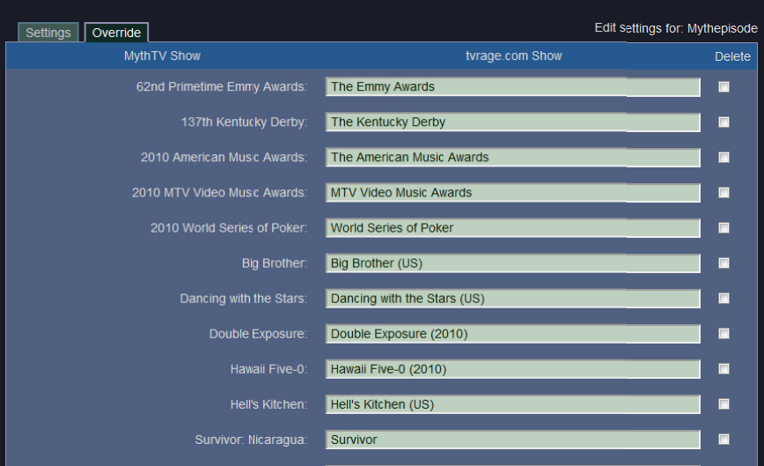

This tab is used to configure shows to display properly in mythepisode that have names that don't match. When mythtv records a show it has a specific title that may not match exactly with what is listed in TVRage.com. As a result mythepisode doesn't know how to display that show on the recorded page.

**Examples:**

**Recorded by mythtv as:** **Listed in mythepisode as:**

Survivor: Nicaragua Survivor

2010 MTV Video Music Awards MTV Video Music Awards

Hawaii Five-0 Hawaii Five-0 (2010)

The Amazing Race 17 The Amazing Race Big Brother (US)

Big Brother Big Brother (US)

Hell's Kitchen Hell's Kitchen (UK)

This problem can be overcome by adding them in the override tab. By default if mythepisode finds and issue with a show that can’t be matched it will add it to the override tab. It is up to you to fill in the missing show title as displayed in mythepisode and save the configuration. You can easily find it in mythepisode by selecting "All Shows" on the main page and finding the show title as displayed in mythepisode. Now add the mythepisode show title next to the show title in the override tab and save the configuration.

**Common Problems/Solutions:**

**Problem:** Fatal error: Class 'Schedule' not found in /usr/share/mythtv/mythweb/modules/tv/includes/recording_schedules.php on line 74

**Solution:** This usually indicates that the version of mythtv selected in the mythepisode configuration options is not correct. It may be set to .24+ but should be set to something lower.

**Problem:** Warning at /usr/share/mythtv/mythweb/modules/episode/episodes.php, line 157:

!!NoTrans: Invalid argument supplied for foreach()!!

**Solution:** This usually indicates that the version of mythtv selected in the mythepisode configuration options is not correct. It may be set to .23 or lower but should be set to .24+.

**Problem:** I have previously recorded a show that doesn’t show up on the mythepisode recorded page.

**Solution:** The show title probably doesn’t match the title that tvrage.com has listed. Go to the mythepisode configuration page, select the override tab, find your show and update the title.

**Screenshots:**

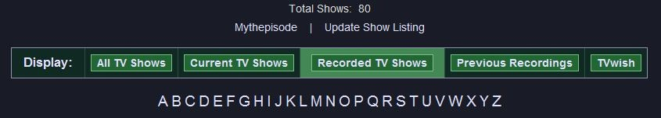

“Total Shows” when “Recorded TV Shows” is selected indicates how many shows (Not episodes) have been recorded to mythtv.

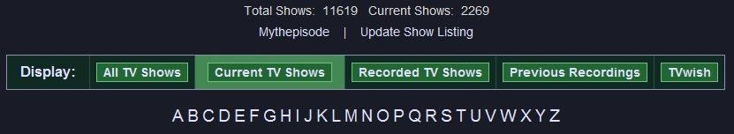

“Total Shows” when “All TV Shows” or “Current TV Shows” is selected indicates how many shows (not episodes) are available from tvrage.com for the country/countries selected.

“Current Shows” indicates how many shows are currently active TV shows.

Selecting “Update Show Listing” goes to tvrage.com and downloads the latest list of TV shows.

The alphabetical listing A-Z allows for easy navigation to shows.

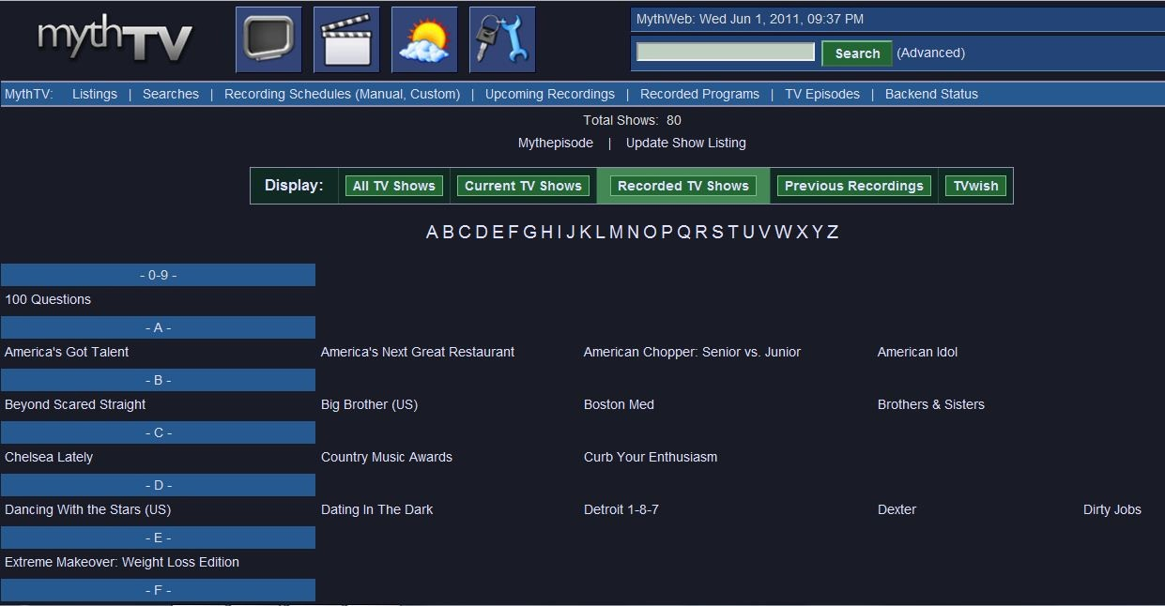

“Recorded TV Shows” is an alphabetical listing of shows that have had at least one episode recorded by mythtv.

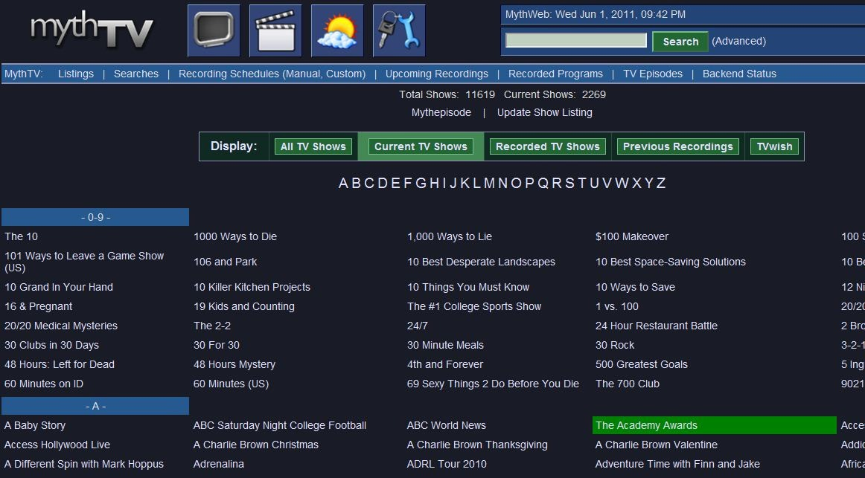

“Current TV Shows” includes TV shows that are currently active running TV series. Shows that are highlighted in green indicate that the user has recorded one or more episodes of the TV show.

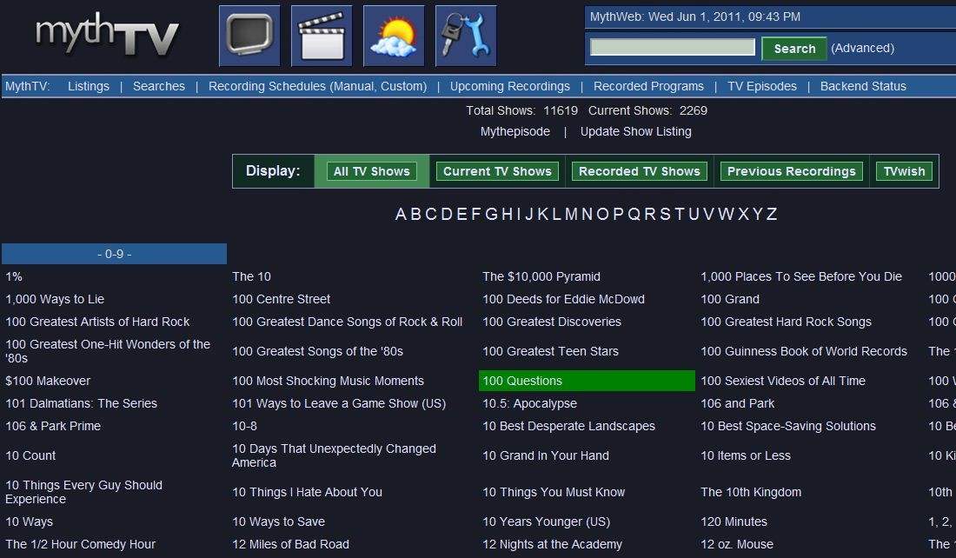

“All TV Shows” is a comprehensive list of almost every TV series that has ever aired. Shows that are highlighted in green indicate that the user has recorded one or more episodes of the TV show.

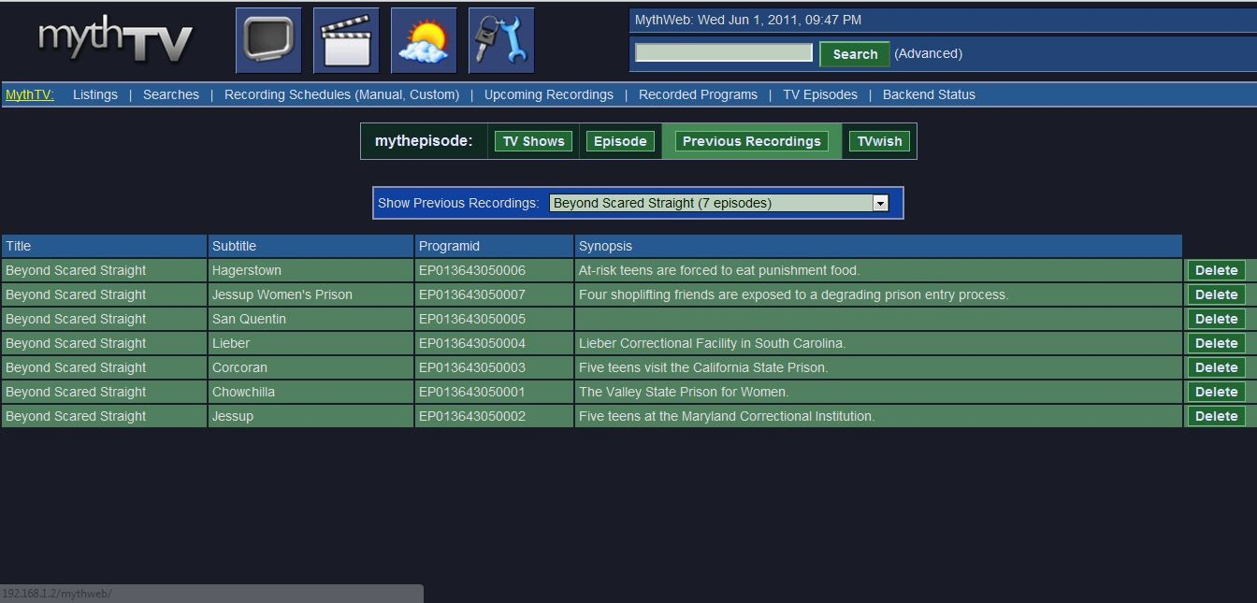

From the “Previous Recordings” window the user can select a show and display all episodes that have been recorded. Selecting the “Delete” button will remove the episode from the mythtv databas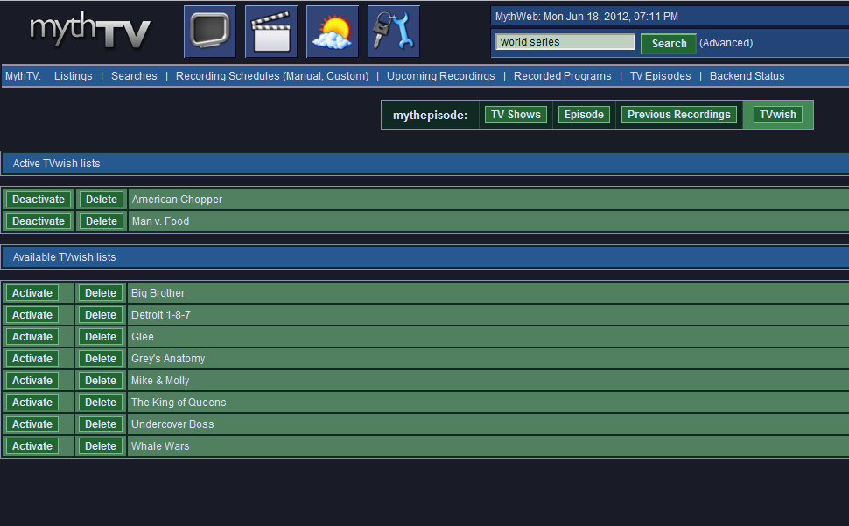

This screenshot shows a list of TVwish recording rules. The shows in the Master list will record episodes that are part of that list. The shows in the Available list can be activated by selecting the “Activate” method to the left of each show. Likewise a show can be deactivated by selecting the “Deactivate” method to the left of the show.

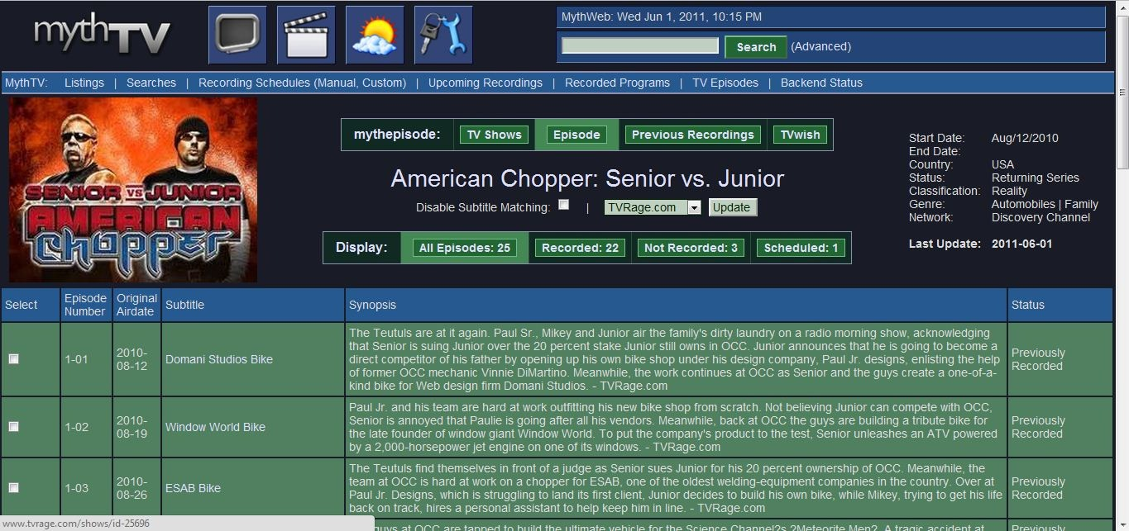

This screenshot is what is displayed when the user selects a show from the main window. The show is displayed with a thumbnail that if hovered over displays a synopsis of the show. To the right you will see information pertaining to the show such as Start Date, End Date, Country, Status, Classification, Genre, and Network. The last time the information was updated is also displayed.

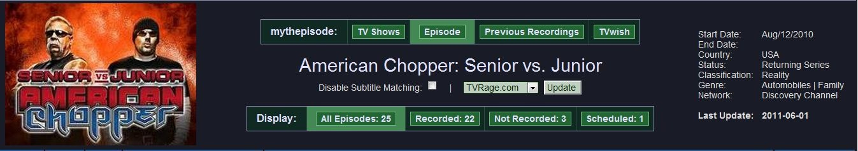

The middle section displays the show title which can be clicked on to take the user to the show at tvrage.com/thetvdb.com. Selecting the checkbox “Disable Subtitle Matching” is used to disable subtitle matching which will force mythepisode to only match on the airdate. This is useful for shows that have many episodes with the same subtitle. The user can select to update episode information by selecting either TVRage.com or TheTVDB.com and performing an update. This will update all episode information listed and change the “Last Update:” date to today’s date.

The Display section is used to show “All Episodes”, “Recorded” episodes, “Not Recorded” episodes, and “Scheduled” episodes. Clicking on any of these will display the respective information.

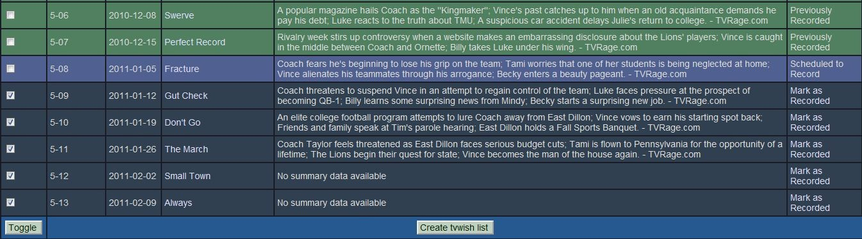

Episode listings will have several colors indicating different things. Green indicates that the episode has been previously recorded. This is also indicated to the right of the episode. Purple/blue indicates that the episode is scheduled to record. Dark grey indicates that the episode is not recorded or scheduled to record. The checkbox to the left of these episodes are used to schedule them for recording if the “Create tvwish list” button is selected. These episodes also have a “Mark as Recorded” button the right of the episode. The user can mark an episode as recorded if they have seen/recorded the episode in the past. This will update the mythtv database with the necessary information.

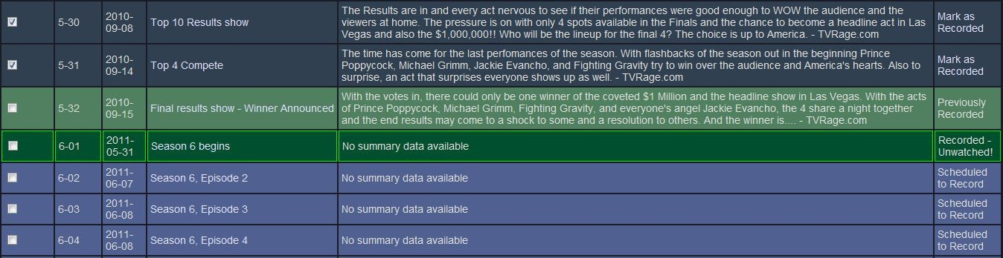

If an episode has been recorded, but hasn’t been watched it is displayed in bright green and is listed as “Recorded - Unwatched!”.

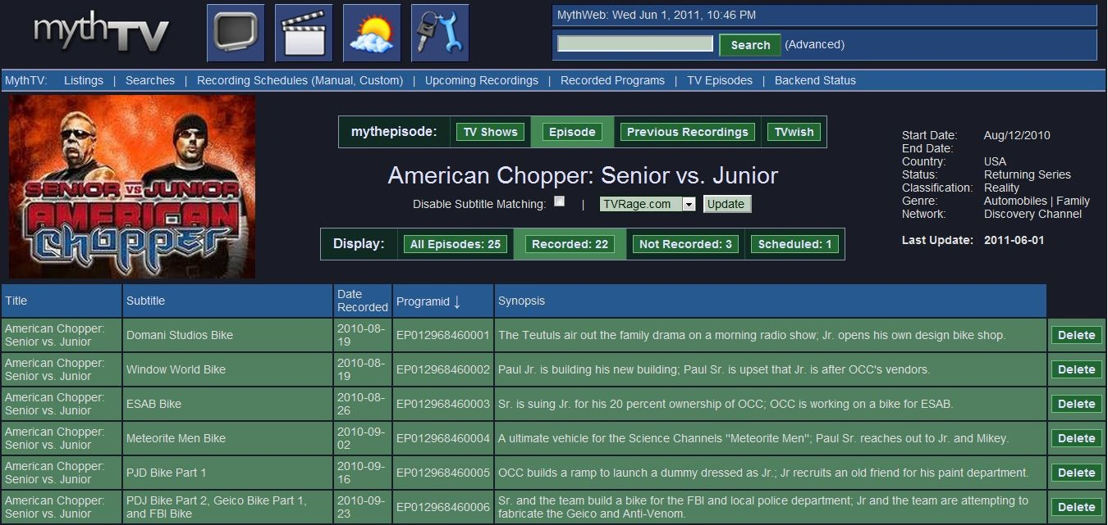

Selecting “Recorded” displays all episodes for a show that have been recorded. “Delete” next to the episode can be selected to delete the episode from the mythtv database.

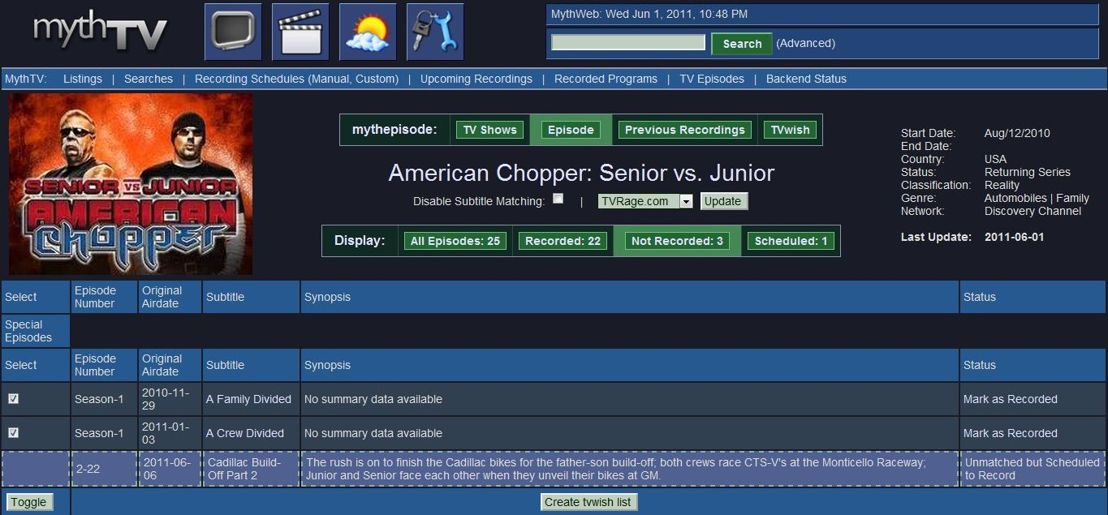

Selecting “Not Recorded” displays a list of all episodes that haven’t currently been recorded.

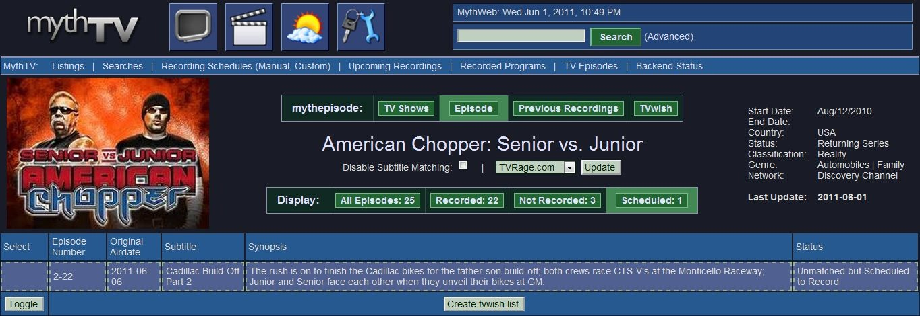

Selecting “Scheduled” displays a list of all episodes scheduled to be recorded.